**TCP/IP LAYERS**

|  |
| --- |
| APPLICATION |
| PRESENTATION |
| SESSION |
| TRANSPORT |
| NETWORK |
| DATA LINK |
| PHYSICAL |

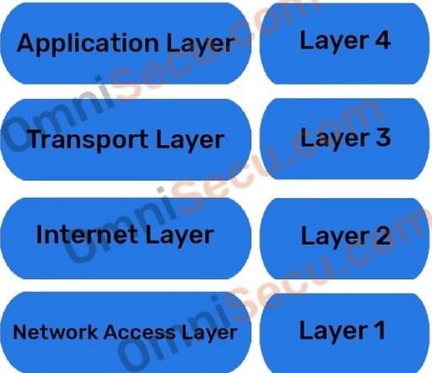

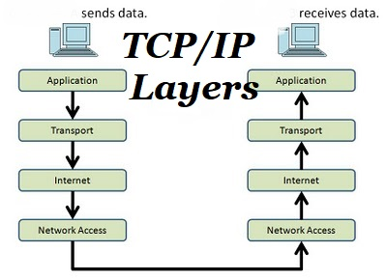

|  |
| --- |
| server |

Internet

system